Download, Upload, Load

Unit 1 - Lab 6

Directions: Follow along with the slides and answer the questions in **red** font in your journal.

# Download, upload, load

* Before we can perform any analysis, we have to load data into R.
* First, identify the data we want to analyze. Then
  + **Download** the data onto the computer
  + **Upload** data to RStudio server
  + **Load** data into R's working memory

# Downloading

* To begin, go to the [Mobilize Landing Page](https://lausd.mobilizingcs.org/landing/).
  + Click on the **Web Frontend**
  + Fill in your username and password and click "Sign in."

If you forget your username or password, ask your teacher to remind you.

# Mobilize web front end

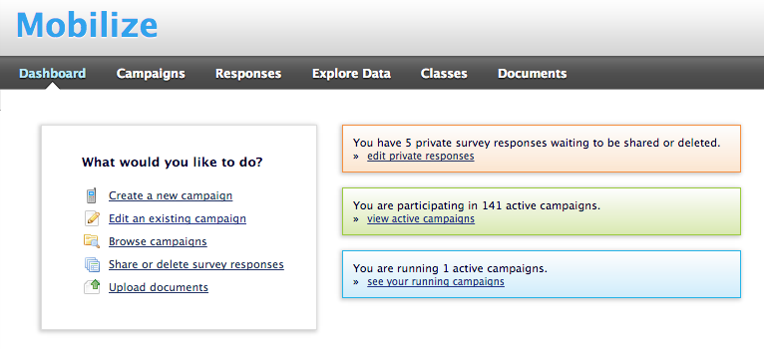

* After logging in, your screen should look like this.
* Click on the **Campaigns** tab.

# Campaigns tab

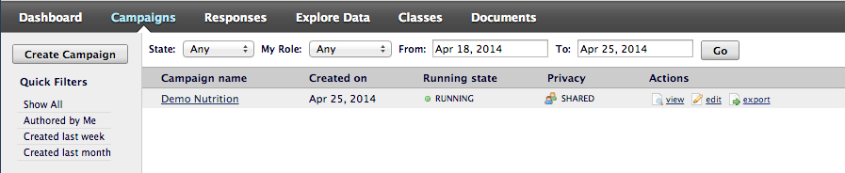

* When you click on the campaigns tab your screen should look something like this.
* Find the campaign you would like the data for:
  + At the right side of the screen, look for the link labeled **Export** Click it.
  + Remember where you save your file!

# Downloading

* When you clicked the **Export** link a *csv* file was saved on your computer.
* Now that the file is on your computer, we need to **upload** it into RStudio.

# Uploading

* Look at the four different *panes* in RStudio.
  + Find the *pane* with a **Files** tab.
  + Click it!

# Uploading

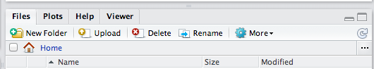

* Click the button on the Files pane that says "Upload"
  + Find the SurveyResponses.csv file you saved to your computer.
  + Hit the *ok* button a few times.
* Voila!
  + If you look in the **Files** tab, you should be able to find your data!

# A word on staying organized...



* The **Files** tab has a few other features to help keep you organized.
  + *SurveyResponse* probably isn't the best name for your data. Click **Rename** to give it a clearer name.
  + If you click on **More**, you'll find an option to **Move** your data. You might consider keeping all of your data files together by **Move**-ing your data into the same folder.

# Loading

* By **Uploading** your data into RStudio you've really only given yourself access to it.
  + Don't believe me? Look at the **Environment** tab ... where's your data?
* To actually use the data we need to **Load** it into your computer's memory.
* R can't remember all the datasets we have at once, which is why there's a seperate step between **Uploading** and **Loading**.

# Loading

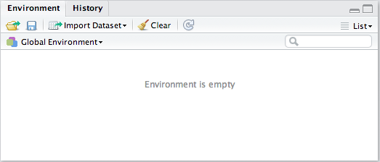

* At the top of the Environment pane, click the "Import Dataset" button. Then, choose "From Text File."
* Find your *SurveyResponse* data and then click *Open*.

# Data Preview

* Give your data a **Name**. This is the name you'll use in your code.
* When you're ready, click the *Import* button.

# read.csv()

* After you click import you might notice something appeared in your console.

data.file <- read.csv("~/SurveyResponse.csv")  
View(data.file)

* We can actually **Load** the data without clicking the button!
  + This would allow you to load data by writing code!
  + This might come in handy later in the course.

# Download, upload, load

* It's time to play with data!